

Dr G Wilkinson & Partners

Manor House Glossop and Hadfield

Fair Processing Notice for Patients

Written By: Alison Bowler  Jennifer Pitts  Signed: 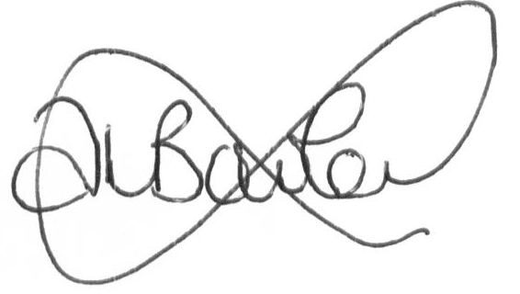  Date: 30.04.2018 | Authorised by: Dr Veena Jha (Lead GP Glossop)  Dr Susan Moore (Lead GP Hadfield)  Signed: 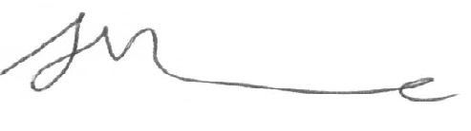  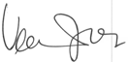  Date: 30.04.2018
Job Title: Practice Manager
IT & Data Manager
Effective Date:  April 2018 | Review Date:  January 2020

Document Control Page

N:\P Drive\Information Governance staff policies

Document  Version | Comments | Date
1.0 | New | April 2018

Your Information, Your Rights

As your GP practice, we are a ‘data controller’ for any information
that we keep about you and your health.

This Privacy Notice tells you what information we collect about you,
how we store it, and who we share it with - and the reasons why.

All of the different information we keep about your health is looked after
by the staff who look after you. Only the doctors and nurses you have appointments with will be able to access to your information.
The information can only be viewed when absolutely necessary.

What type of information do we keep about you?

- ‘Personal data’. This means any information that can identify who you are.
This includes your name, date of birth, full postcode, address and next of kin;

and
- ‘Special category / sensitive data’. This means any information about your medical history. It could be when you have come in for appointments, medication you have been given, notes about your care, or treatments.
It could also be social care status, race or ethnic origin.

The personal information we keep about you is to help us provide health or social care or treatment, under the Data Protection Act (DPA) 2018.

Where do we keep your records?

Your personal information is held in both paper and electronic forms for specific amounts of time.

We will always make sure:
- Your records are accurate
- Your records are secure
- You can access your records

What do we do with your information?

Your records are used to manage and deliver your care. This helps us make sure:
- The practice staff have all of the information they need to help them provide you with the best care for your needs.
- The practice staff involved in your care have correct and up-to-date information about you.
- The right information is available in case you see another healthcare professional, or need to see a specialist, social care or health care provider.

Who do we share your information with?

We may need to share information with other organisations such as:

- NHS England
- Public Health England
- Other GP practices, hospitals or ambulance services
- Social Services

What are your rights?

If we need to use your personal information for any reasons that isn’t listed above, we will discuss this with you or your parent(s) / guardian(s) to obtain consent, depending on your circumstances.

The DPA 2018 means that you or your parent(s) / guardian(s) may have the right to:

- Ask to see the personal data we hold about you, such as health records.
- Ask us to correct information in your health records that you think is wrong or incomplete.
- Refuse or take away consent for us to share your health records with others – an example could be using your information for research purposes.
- Ask us to send your personal information to other healthcare providers.
A member of the practice team will make a decision about
whether you can do these yourself, or if it is more appropriate
to involve a parent / guardian.

If you have any questions you can contact
Information Governance lead
at Manor House Surgery

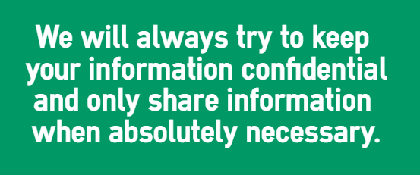

A full copy of the Fair Processing Notice is available via our website at
www.manorhousesurgery.co.uk or from our Reception.

